BEST VALUE OF MONEY
Pearson Edexcel - Friday 6 November 2015 - Paper 2 (Calculator) Higher Tier
1.
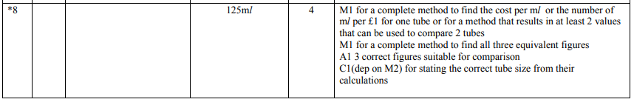
Pearson Edexcel - Monday 8 June 2015 - Paper 2 (Calculator) Higher Tier
2.
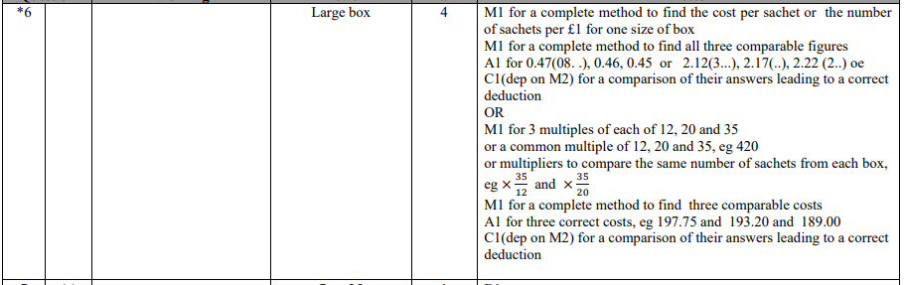
Pearson Edexcel - Monday 9 June 2014 - Paper 1 (Non-Calculator) Higher Tier
3.
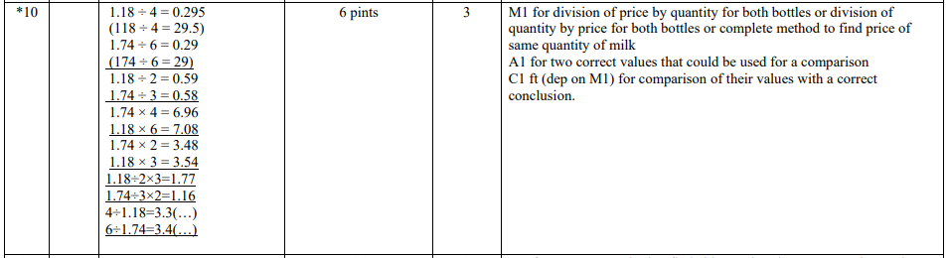
Pearson Edexcel - Friday 8 November 2013 - Paper 2 (Calculator) Higher Tier
4.
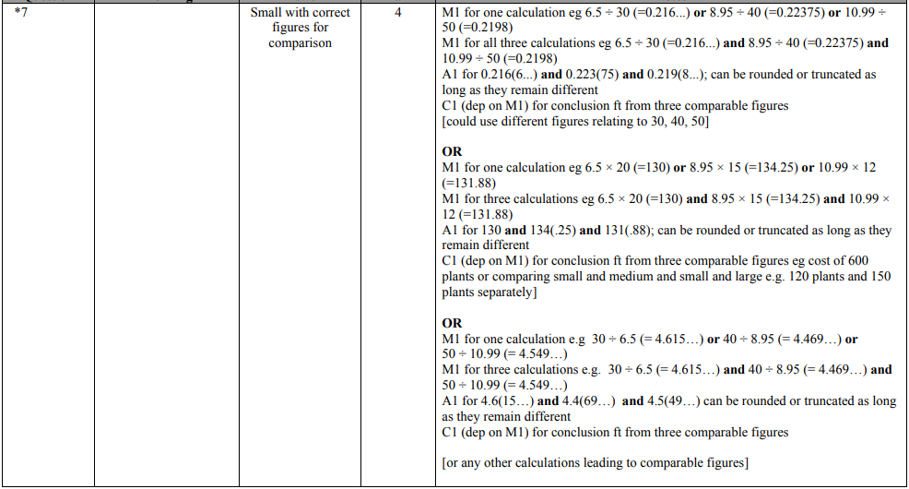
Pearson Edexcel - Tuesday 10 November 2009 - Paper 4 (Calculator) Higher Tier
5.
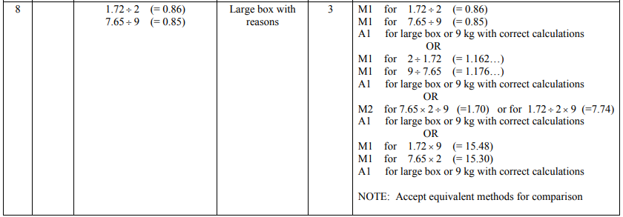
AQA GSCE – Wednesday 25 May 2017 – Paper 1 (Non - Calculator) Higher Tier
6.
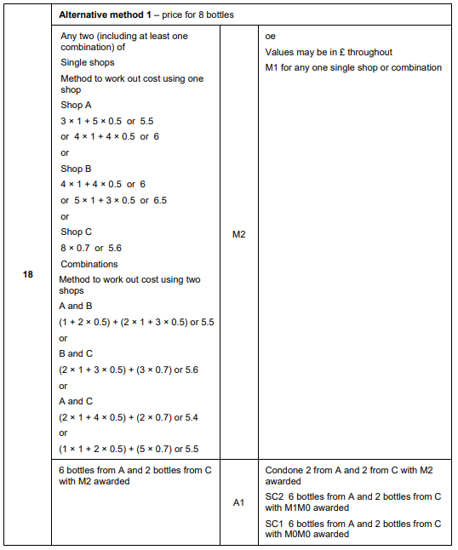
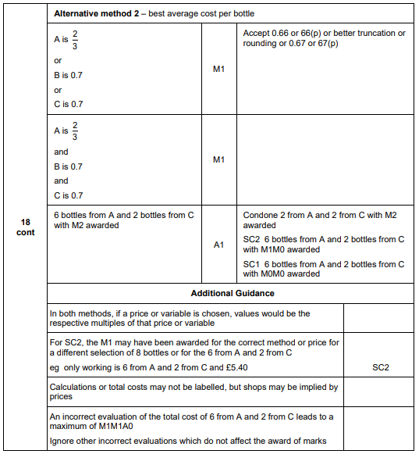
AQA GSCE – Sample Paper 2 (Calculator) Higher Tier
7.
